Visualiser Manual Tests

1. Linked Source Folder (bug 48624)

- Install AJDT and the TJP example. Move the ‘src’ directory to a location outside the workspace and delete the ‘bin’ directory.
- Create a new folder and link it to the ‘src’ folder that you moved. (Right click on the project, then click ‘New’ > ‘Folder’. Enter “src” for the name, then click “Advanced >>”. Check “Link to folder in the file system”, then browse to the location that you moved the original source folder to.
- Build the project and open the Aspect Visualization perspective. Select the TJP project in the Projects view. The Visualiser should show two bars, one of which has three stripes on. The Visualiser Menu should have one entry called GetInfo.

2. Errors and Warnings (enhancement 71626)

- Install the Telecom Example.
- Insert the following line in Timing.java:
declare warning : call(void Connection.drop()) : "call to Connection.drop";
- Insert the following line in Billing.java:
declare error: call(*.new(..)): "Constructor call";
- Rebuild, open the Visualiser and select the Telecom Example project. The Visualiser should look something like this. Check that the Menu only contains Timing and Billing and that there are red and yellow stripes as shown in the main Visualiser view.
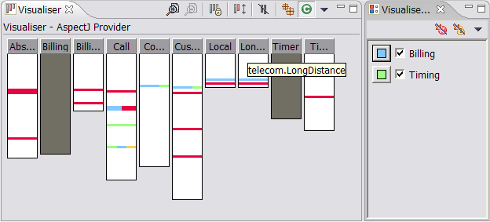
- Click the ‘Hide Errors’ button in the Visuliser Menu and check that all the red stripes disappear.
- Click the ‘Hide Warnings’ button in the Menu and check that the yellow stripe disappears.
- Press ‘Hide Errors’ and ‘Hide Warnings’ again so that error and warning stripes are not hidden. Uncheck Billing in the Menu. The Billing stripes and the red stripes should all disappear. Uncheck Timing. The yellow stripe and the Timing stripes should all disappear.
- Switch providers (see the Visualiser help if you do not know how to do this). Check that the ‘Hide Errors’ and ‘Hide Warnings’ buttons have disappeared from the Menu.

3. Multiple Source folders

- Check out the ‘MultipleSourceFolders’ test project from the org.eclipse.ajdt.tests project on Eclipse.org and build it. Ensure by inspection that the contents of both the ‘src’ and the ‘src2’ source folders are being built.
- Open the Aspect Visualization perspective and select the project. You should see three bars in the Visualiser labelled ‘Class1’, ‘Class2’ and ‘Class3’.
- Select the default package under ‘src’. You should see one bar labelled ‘Class1’ in the Visualiser.
- Select the package ‘pack’ under ‘src’. You should see one bar labelled ‘Class2’ in the Visualiser.
- Select the package ‘pack’ under ‘src2’. You should see one bar labelled ‘Class3’ in the Visualiser.

4. Colour Persistence (bug 72368)

- Install the Tracing example and the TJP example. Open the Aspect Visualization Perspective and select the Tracing example project in the projects view.
- Using the Visualiser Menu change the colour for one of the aspects listed. Switch to the TJP example, then switch back to the Tracing example in the project view. Check that the aspect that you changed still has the colour you selected.
- Select a different build configuration for the Tracing example and rebuild. If still included in the build check that the aspect you changed the colour for still has that colour. Otherwise rebuild again with the original configuration and check that your colour change is still in effect.
- Restart the workbench and check again that your colour change is still in effect.

5. Hidden Menu Bug

- Hide the Menu behind the Visualiser or another view and restart the workbench.
- Make some selections in the Package Explorer and ensure that the Visualiser performs correctly. It should act as if the menu is there and has everything selected.

